State vs. Federal
Federalism -is a system of government in which the same territory is controlled by two levels of government.
Create a double bubble using the following powers.
To tax
Print money
To build road and maintain roads
Set up schools
Convict criminals

To declare war
Establish marriage laws
Establish a post office
Hold elections
Establish foreign policy
Establish local governments

Concurrent/Shared Powers

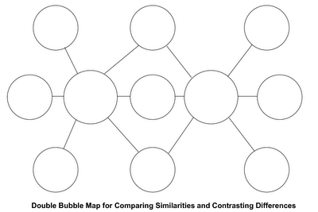
Reserve/State Powers
Expressed/National Powers

