Important People, Places and Terms: Define each of these terms in your own words (used in the manner required by the lecture), and write a sentence using it correctly. (2 points Each)
- Viceroy

- Encomienda

- Bartolome de Las Casas

- Peon

- Peninsular

- Creole

- Mestizo

- Mulatto

- Privateer

Application of Knowledge:
- How did Spain and Portugal build colonies in the Americas?

- Explain how Spain ruled its empire in the Americas.

- Describe how Portugal and other European nations challenged Spanish power.

Using the charts below answer the following questions:
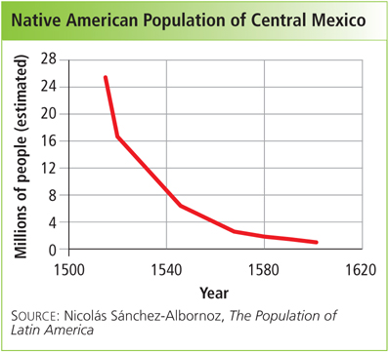
- Based on the trends on this chart, hypothesize what the graph would look like if it stretched out to modern day.

- List some of the causes of the decline of the Native American population.

Fill out the Chart Below
Peninsulares
Creoles
Mestizos and Mulattoes
Native American and African

